RESUME

Dharsandia Krishna
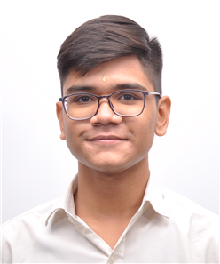

passport size
photo
“UMA KRUPA” uday nagar 1,
Street 17 near sardar nagar ,
Movdi main road Rajkot,
360004
+91 8490040874
+91 9824840874
kp064342@gamil.com

- Objective :
To seek a challenging postion in reputed organisation where I develop my personal and professional skill ,expand my personal capacity development of organisation will be tried and then personal worth.

- Academic qualification :

Degree | School/College | Board /University | Passing year | Result
M.E / C.E | Atmiya University | G.T.U | 2029 | 8.1
B.E | Atmiya University | G.T.U | 2026 | 8.0
Diploma | Atmiya University | A.U | 2024 | 8.0
S.S.C | Dholakiya School | G.C.E.B | 2021 | 80%

- Extra qualification :
- Have completed diploma certificate course on ceative writing in English from Gujarati external centre Gandhinagar from six months between 1st January to 31 june 2020.
- Have completed A.I.T.C.E offered certificate course on C++ from Amdabad between 1st june to 30 September.
- Got 1st rank in Essay Writing compition organization by rajkot municipal corporation 2018.

- Receive student award from Atmiya University Rajkot in 2022.

- Skills :

- technical skills : Ms Office , Java , HTML , PHP.

- Soft skill :

- communication skills , life skills , leadership skills , management skill.

- Personal detail :

Full name | Dharsandia Krishana Nileshbhai
DOB | 25/09/2005
Hobby | Swimming
Married status | -
Nationality | India

- Declaration :

All the information about are True and othentic as per my knowledge for othainted all are At’s after.

- Reference:

Miss bumika Zalavadiya,
head of the department
Diploma in computer
Atmiya University
Mr karan Dave,
C.E infotech PVT
+91 9929298788
Ahmedabad

Place : Rajkot Signature
Date : 11/04/2022

